1. Error when using command "docker image build -t python-hello-world .

/var/folders/xl/ffnfgz9n1gsg8q7c2wwxqfg80000gn/T/com.microsoft.Word/WebArchiveCopyPasteTempFiles/p26

           Because “python-hello-world” in command is image name, not the **dockerfile** name, so it’s not found. In docker, all dockerfile name is named “Dockerfile”, could not be named other names.

1. Error when **pushing** private image to Docker Hub registry.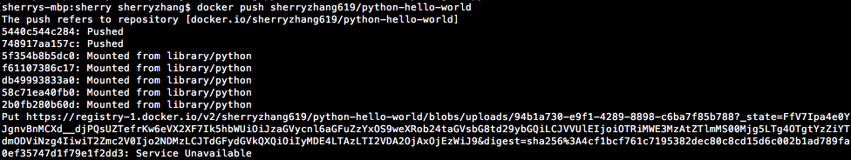

          推送Docker Hub速度很慢，耐心等待，很有可能失败，失败会尝试多次重传，之后断开推送（但已推送上去的会保留，保留时间不知道是多久）

1. Error when trying to **mount** a local repository to docker container.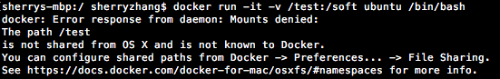

          容器启动会自动创建/soft的目录，即冒号":"前面的目录是宿主机（本地）目录，后面的目录是容器内目录，都必须是绝对路径。Command should be “docker run -it -v /Users/test:/soft ubuntu /bin/bash"

1. Error: Unable to locate package sudo

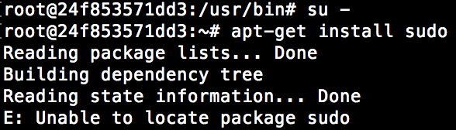

          需要run命令apt-get update再安装软件。

1. Error when trying to run python file using python3.5

/var/folders/xl/ffnfgz9n1gsg8q7c2wwxqfg80000gn/T/com.microsoft.Word/WebArchiveCopyPasteTempFiles/p36

          change command to “python3.5 baidu.py”

1. **UnicodeEncodeError:** Ascii codec can’t encode characters in position…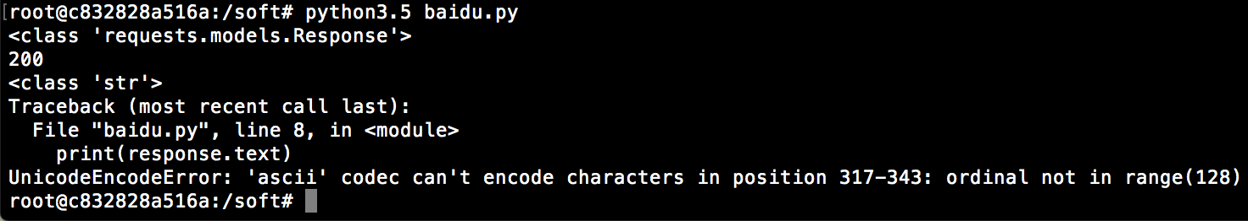运行python脚本的时候写成 PYTHONIOENCODING=utf-8 python3.5 baidu.py，如果想直接在python3.5里查看，可以用PYTHONIOENCODING=utf-8 python3.5命令进入python3.5
2. Runtime Error: Could not find firefox in your system PATH.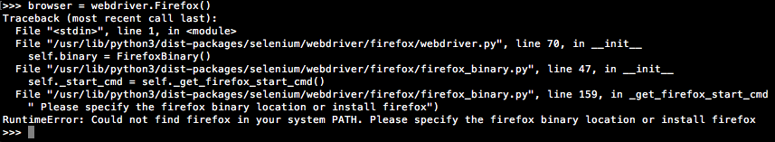
3. Error: Not find brew command

/var/folders/xl/ffnfgz9n1gsg8q7c2wwxqfg80000gn/T/com.microsoft.Word/WebArchiveCopyPasteTempFiles/p40

          run: ruby -e "$(curl -fsSL <https://raw.githubusercontent.com/Homebrew/install/master/install>)”